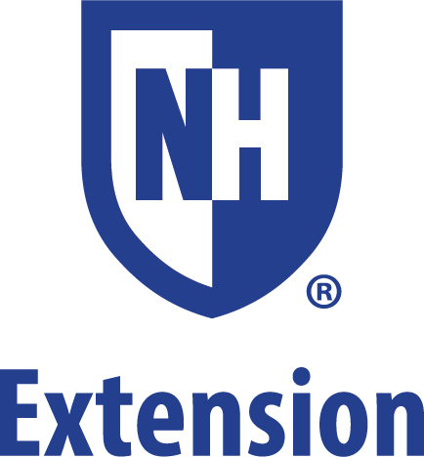

Summer 2019

Dear Barry Conservation 4-H Camp Families:

Everyone at Barry Conservation 4-H Camp is very concerned about your childs health and safety while at our camp this summer. Traditionally, we keep all medications locked in the camp health care center and distributed them under specific guidelines and documentation procedures. However, we realize that for certain medications and specific health concerns, this procedure may not meet your childs needs this summer.

IF YOUR CHILD BRINGS AN ASTHMA INHALER OR EPINEPHRINE AUTO-INJECTOR
(epi-pen) TO CAMP due to their asthma or severe allergies, you have the following options:

- The inhaler and/or epi-pen will be kept locked in the camps health care center and be available for use as it can be accessed by staff. This has been our typical practice in the past.

- The inhaler and/or epi-pen can be kept in the possession of your child. However, in order to comply with recent State of NH legislation, the attached permission slip MUST be signed by your childs physician in order for your child to carry an inhaler or epi-pen in her/his possession while at camp. Please mail with other paperwork before arriving at camp or bring this signed form with you on the first day of camp.

- Without the signed permission slip on file at camp, your child cannot keep such medication in her/his possession and it will be locked in the health care center.

Campers who possess an inhaler and/or epi-pen are expected to report all medication usage to the nurse or camp director. This allows for the proper monitoring and documentation of medication usage by our nurse or camp director. We recommend that a second epi-pen or inhaler be brought to camp and stored in the health care center as a back-up to the one your child keeps in her/his possession.

Camp counselors will be aware of campers who are authorized to keep epi-pens and/or inhalers in their possession. Our counselors will check-in with campers when appropriate, such as before leaving on a field trip, but the counselors are not responsible for ensuring that campers have these medications with them. We ask that you please carefully consider your child's capabilities before deciding who will be responsible for his/her medications.

Thank you for your time with this matter. If you should have any questions, dont hesitate to contact us at (603) 788-4961 or by email: 4hcamps@unh.edu

PERMISSION TO POSSESS AND USE
EPINEPHRINE AUTO-INJECTOR AND / OR ASTHMA INHALER AT
Barry Conservation 4-H Camp 2019
________________________________________ (name of camper) is attending Barry Conservation 4-H Camp this summer. The following information is on file at the camp in the campers health form or will be provided on the original label of prescription medication brought to camp:

- The childs name.
- The name and signature of the licensed prescriber and business and emergency numbers.
- The name, route, and dosage of medication.
- The frequency and time of medication administration or assistance.
- The date of the order.
- A diagnosis and any other medical conditions requiring medications, if not a violation of confidentiality or if not contrary to the request of the parent or guardian to keep confidential.
- Specific recommendations for administration.
- Any special side effects, contraindications, and adverse reactions to be observed.
- The name of each required medication.
- Any severe adverse reactions that may occur to another child, for whom the epinephrine auto-injector is not prescribed, should such a child receive a dose of the medication.

As the childs physician, I give permission for this child to possess and use (please identify which medication):

_____ EPINEPHRINE AUTO-INJECTOR

_____ ASTHMA INHALER

My signature below provides verification that this child has the knowledge and skills to safely possess and use the identified medication(s) in a camp setting.

Physicians Signature

Date

Physicians Printed Name

Address

Phone Number

