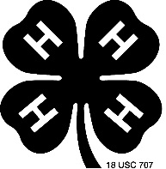
LIFE SKILLS USED IN 4-H
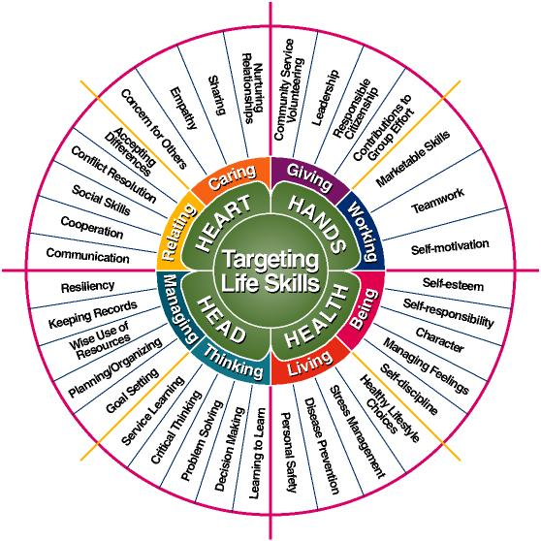
With Colored pencils or highlighter, color in all of the life skills you used while completing this year’s 4-H project.

