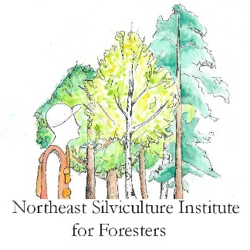
Northeast Silviculture Institute
Northern Hardwoods
Forest site conditions and associated treatments
September 5, 2018

Assignment details
The goal of this assignment is to apply the knowledge gained through today’s presentations, field trip and your previous experience to develop a rapid assessment of the site conditions in our final two field trip stops.

Form a small group. At each site, complete the worksheet forest site conditions and associated treatments. Submit one group worksheet by Thursday morning before the session begins on this webpage (http://www.northeastsilvicultureinstitute.org/2018-northern-hardwood-session/ see “Upload your assignment”). You can download this worksheet from that webpage for your use. When naming the file, use at least one last name of a person in your group.
Group Members_____________________________________________________________

- Stop 1 (Compartment 26):
  - Overall site quality (low, medium, high)

  - Crop tree species based on site

  - Forest attributes and indicators used to make site assessment

  - Next logical silvicultural treatment to apply in the next entry to this stand? Make sure to justify your answer.

  - Describe the general wildlife habitat conditions in this stand. What species do they likely support? What effect will your silvicultural prescription have on the wildlife habitat?

- Stop 2 (Compartment 19):
  - Overall site quality (low, medium, high)

  - Crop tree species based on site

  - Forest attributes and indicators used to make site assessment

  - Next logical silvicultural treatment to apply in the next entry to this stand? Make sure to justify your answer.

  - Describe the general wildlife habitat conditions in this stand. What species do they likely support? What effect will your silvicultural prescription have on the wildlife habitat?

