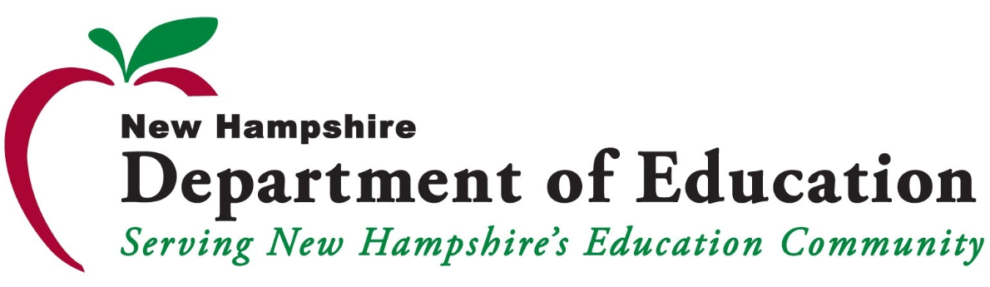

Triennial Assessment Tracking Form
Date of Assessment:
Name of School/District/SAU:
Nutrition Education Goal(s) | Notes | Goal Status (select one):  Completed  Partially Completed  In Progress  Not Completed  (click on “Choose an item” to show the drop down menu)
1. |  | Choose an item.
2. |  | Choose an item.
3. |  | Choose an item.
4. |  | Choose an item.
5. |  | Choose an item.
Nutrition Promotion Goal(s)
1. |  | Choose an item.
2. |  | Choose an item.
3. |  | Choose an item.
4. |  | Choose an item.
5. |  | Choose an item.
Marketing of Foods in Schools/RCCIs Goal(s)
1. |  | Choose an item.
2. |  | Choose an item.
3. |  | Choose an item.
4. |  | Choose an item.
5. |  | Choose an item.
Foods Sold to Students During the School Day Goal(s)
1. |  | Choose an item.
2. |  | Choose an item.
3. |  | Choose an item.
4. |  | Choose an item.
5. |  | Choose an item.
Foods Provided but not Sold to Students During the School Day
1. |  | Choose an item.
2. |  | Choose an item.
3. |  | Choose an item.
4. |  | Choose an item.
5. |  | Choose an item.
Physical Activity Goal(s)
1. |  | Choose an item.
2. |  | Choose an item.
3. |  | Choose an item.
4. |  | Choose an item.
5. |  | Choose an item.
Other School-Based Activities that Promote School Wellness Goal(s)
1. |  | Choose an item.
2. |  | Choose an item.
3. |  | Choose an item.
4. |  | Choose an item.
5. |  | Choose an item.
Wellness Policy Leadership/Accountability
1. |  | Choose an item.
2. |  | Choose an item.
3. |  | Choose an item.
4. |  | Choose an item.
5. |  | Choose an item.
Wellness Committee Representation
1. |  | Choose an item.
2. |  | Choose an item.
3. |  | Choose an item.
4. |  | Choose an item.
5. |  | Choose an item.
Notification of the Public
1. |  | Choose an item.
2. |  | Choose an item.
3. |  | Choose an item.
4. |  | Choose an item.
5. |  | Choose an item.
Assessment of Wellness Policy Implementation
1. |  | Choose an item.
2. |  | Choose an item.
3. |  | Choose an item.
4. |  | Choose an item.
5. |  | Choose an item.

USDA Nondiscrimination Statement
In accordance with Federal civil rights law and U.S. Department of Agriculture (USDA) civil rights regulations and policies, the USDA, its Agencies, offices, and employees, and institutions participating in or administering USDA programs are prohibited from discriminating based on race, color, national origin, sex, disability, age, or reprisal or retaliation for prior civil rights activity in any program or activity conducted or funded by USDA. Persons with disabilities who require alternative means of communication for program information (e.g. Braille, large print, audiotape, American Sign Language, etc.), should contact the Agency (State or local) where they applied for benefits. Individuals who are deaf, hard of hearing or have speech disabilities may contact USDA through the Federal Relay Service at (800) 877-8339. Additionally, program information may be made available in languages other than English. To file a program complaint of discrimination, complete the USDA Program Discrimination Complaint Form, (AD-3027) found online at: http://www.ascr.usda.gov/complaint_filing_cust.html, and at any USDA office, or write a letter addressed to USDA and provide in the letter all of the information requested in the form. To request a copy of the complaint form, call (866) 632-9992. Submit your completed form or letter to USDA by: (1) mail: U.S. Department of Agriculture, Office of the Assistant Secretary for Civil Rights, 1400 Independence Avenue, SW, Washington, D.C. 20250-9410; (2) fax: (202) 690-7442; or (3) email: program.intake@usda.gov. This institution is an equal opportunity provider. 1/18

