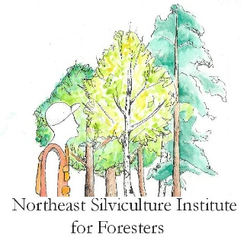
Northeast Silviculture Institute for Foresters
Mixed Oak-Hickory Session
July 12 – 13, 2018
Sturbridge MA and Yale-Myers Forest, Eastford CT

Wednesday, July 11, 2018
Early arrivals check-in to hotel. On your own.

Thursday, July 12, 2018
7:30 – 8:30 AM Register

8:30 – 9:00 Welcome, institute overview including NASP, and introductions—Bob Cooke, Karen Bennett, Charlie Levesque

9:00 – 10:30 Silvics of individual species and stand dynamics—Mark Ashton and Jeff Ward
- Species site requirements, vegetation associations, ecological relationships
- Tree regeneration characteristics, shade tolerance, successional trends, using species characteristics and management objective to determine silvicultural systems
- Stand dynamics including land-use history, climate change, adaptation and restoration

10:30 –10:45 Break

10:45 –11:45 Forest health including identification and management of insects and diseases and impacts of natural disturbances—Isabel Munck

11:45 –12:30 Wildlife considerations—Scott Williams and Michael Gregonis

12:30 – 1:00 Lunch

1:00 – 2:00 Economics, markets and utilization with an emphasis on small woodlots—Tom Worthley

2:00 – 4:30 Silvicultural systems and practices including structure, composition, growth, and regeneration in even- and uneven-aged systems—Mark Ashton and Jeff Ward

4:30 – 5:30 Small group activity

Evening: Dinner on your own, work on assignments and free time

Friday, July 13, 2018, Yale-Myers Forest, Eastford CT
Breakfast on your own
8:00– 5:00 Depart hotel parking lot promptly at 8AM for carpooling and proceed to Yale-Myers Forest. Load into vans and other vehicles at Yale-Myers (150 Centre Pike Rd, Eastford, CT) for field trip covering silvicultural treatments and their effect on stand development. Soils, site quality, productivity silvics and stand dynamics included in all field stops. Forest health and economics, utilization and markets including avoidance of potential logging damage and layout considerations incorporated in some field stops. Bag lunch in the field provided. The entire day is in the field, so be prepared. Field trip leaders: Mark Ashton, Michael Gregonis, Isabel Munck, Jeff Ward, Scott Williams, Jess Wikle and Tom Worthley

5:00 Certificate distribution, goodbyes and safe travels

