You are invited to:
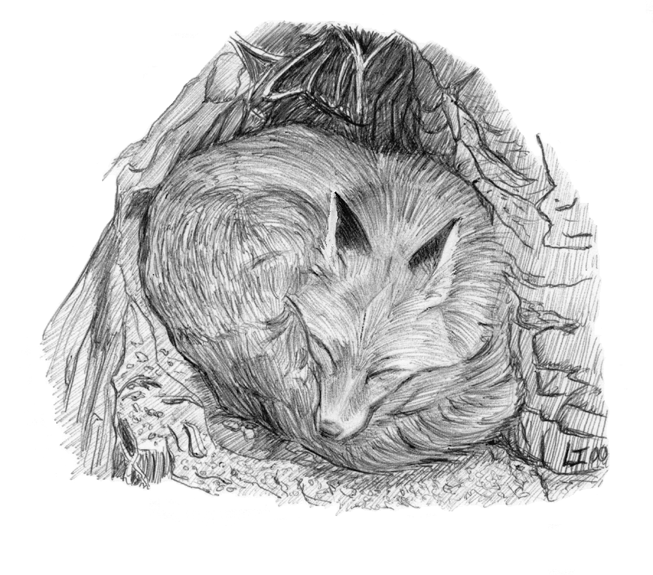
A Speaking for Wildlife Presentation

Birds, Bats & Butterflies:
Keeping Common Wildlife Common
in New Hampshire

Day of Week, Month Day, Year
Time
Name of Building, Name of Town, NH

Have you ever seen a bear in your backyard? A mysterious hawk flying over your birdfeeder? A giant woodpecker that looks like he just stepped out of a cartoon? Come learn about these and the rest of the “Backyard Dozen,” a group of wildlife commonly found in New Hampshire. You’ll learn how to recognize evidence of these species in your backyard and understand how they use different habitats. You’ll also get ideas on how you can help wildlife survive and flourish in your neighborhood.

This program is brought to you by Speaking for Wildlife, a volunteer project of UNH Cooperative Extension, the NH Coverts Project, and NH Fish & Game, with funding support from the NH Charitable Foundation and the Davis Environmental Foundation.
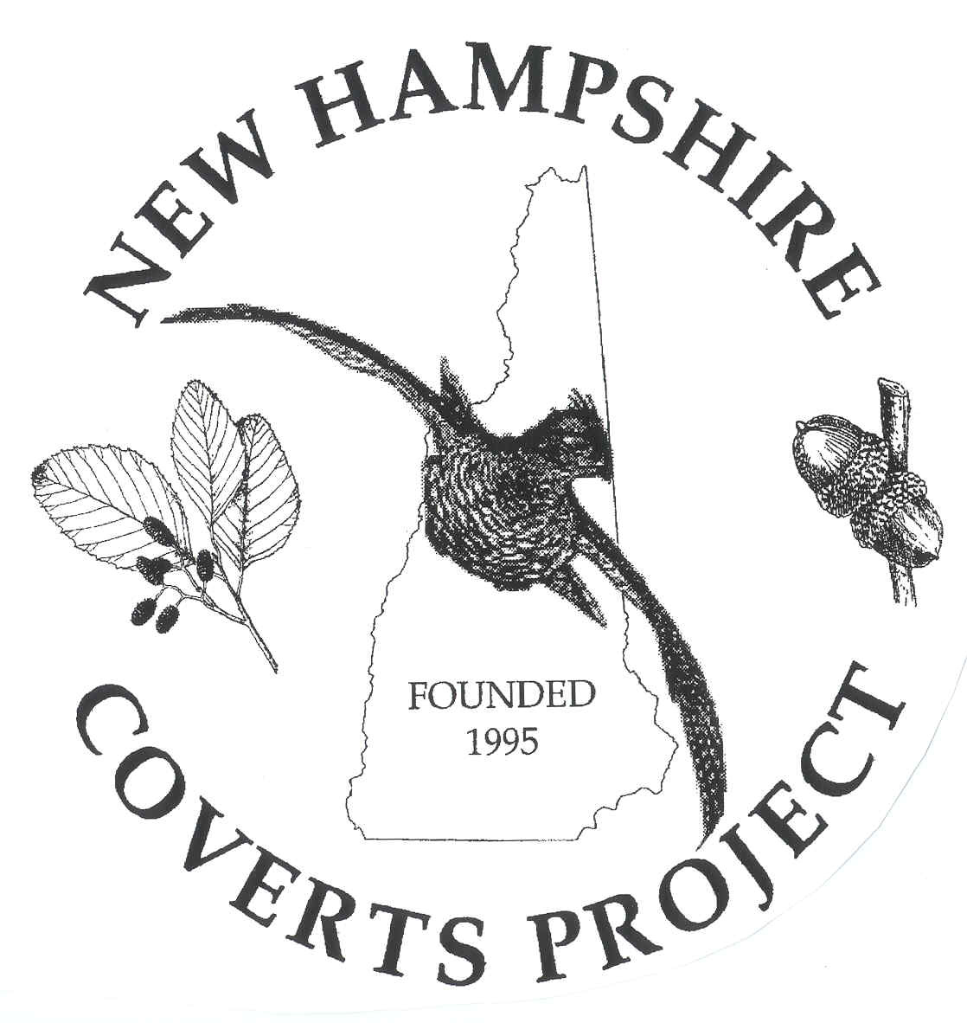
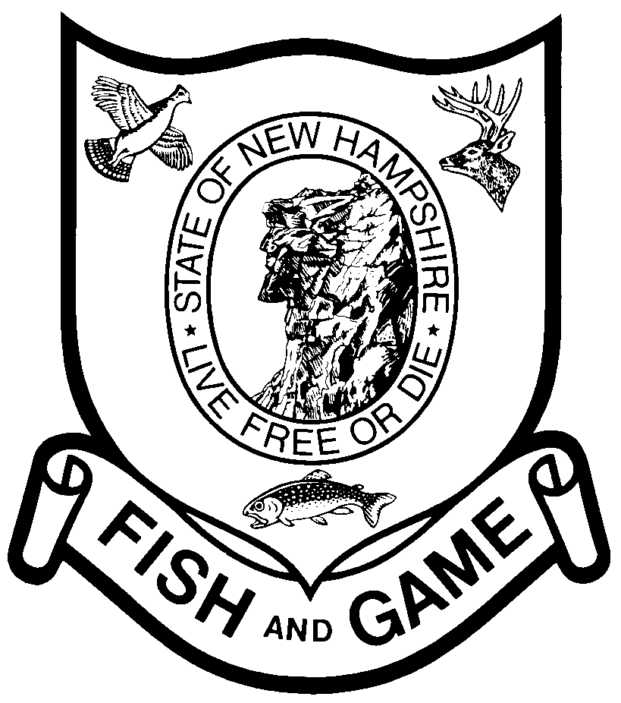



"Helping You Put Knowledge and Research to Work"
The University of New Hampshire Cooperative Extension is an equal opportunity educator and employer. University of New Hampshire, U.S. Department of Agriculture and NH counties, cooperating.

